Formula sheet for EEE 352 11/2022

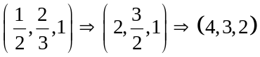, 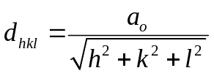, 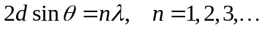
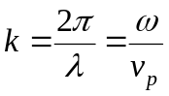
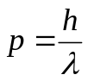,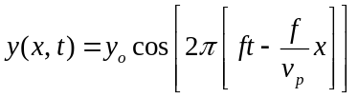 , 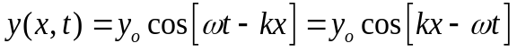,
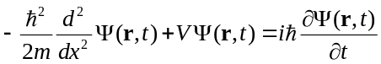, 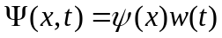, 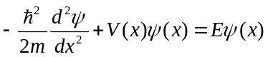, 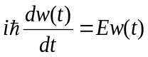
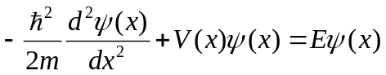, 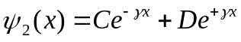, 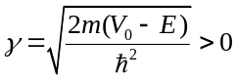
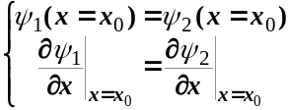
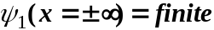
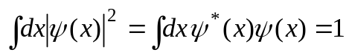

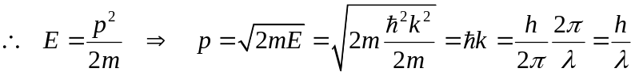, 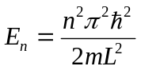, 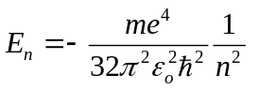
n = 1, 2, 3, …; l = 0, 1, 2, …, (n - 1); m_{l} = 0, ±1, ±2, …, ±l; s = ±1/2
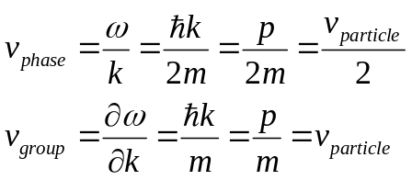, 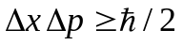, 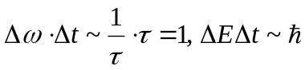
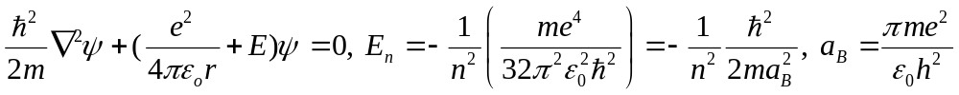
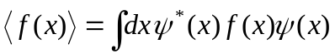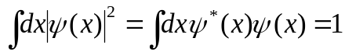

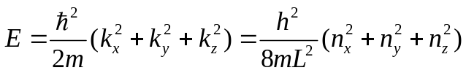, 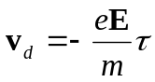, 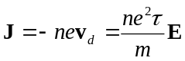,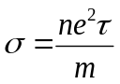, 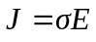
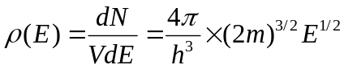,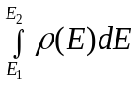, 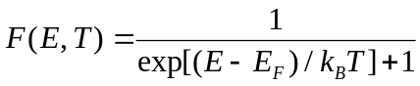, 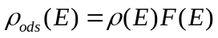
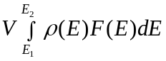, 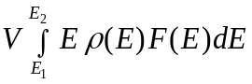,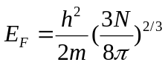,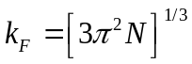, 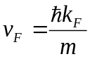, 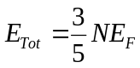
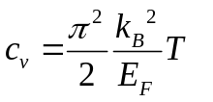< 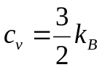, 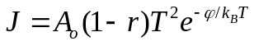, 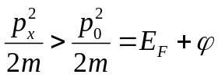

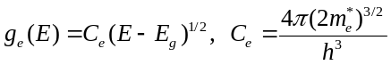, 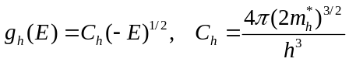
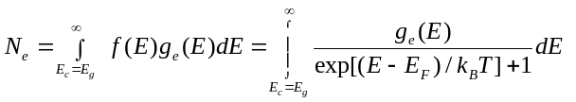,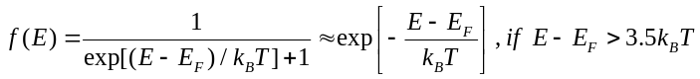
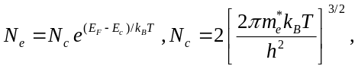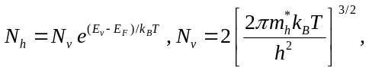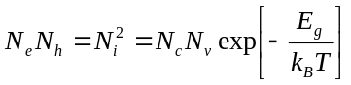

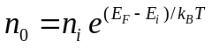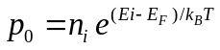

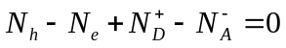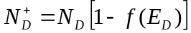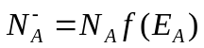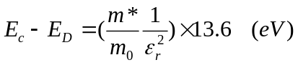

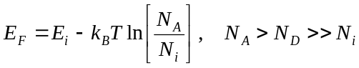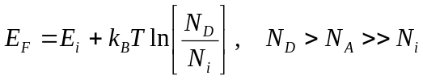

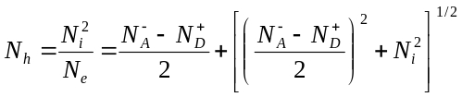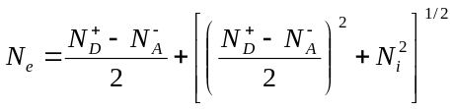

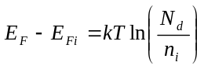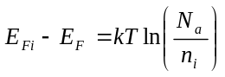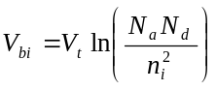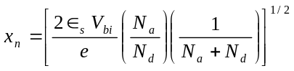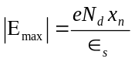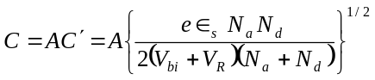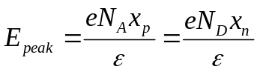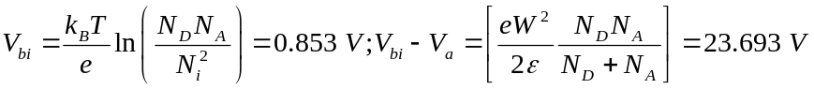

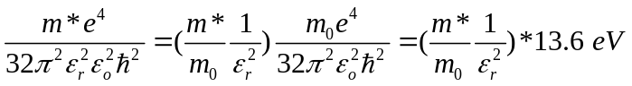

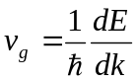,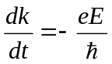,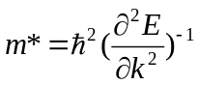,

, ,, 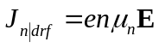, 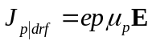,
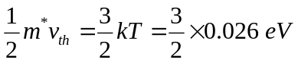

(Please add more by yourselves.)

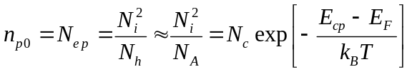
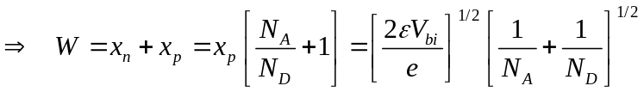, 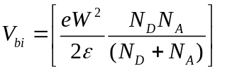

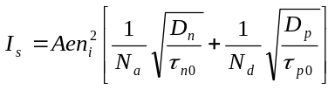
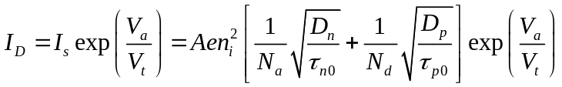
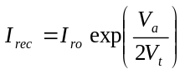 (8.55)

